|  |  |  |  |  |  |  |  |  |  |  |  |
| --- | --- | --- | --- | --- | --- | --- | --- | --- | --- | --- | --- |
|  | Accuracy | Recall | | F1 Score | | Precision | | |  |  |  |
|  | overall | 0 | 1 | 0 | 1 | 0 | 1 | |  |  |  |
| Random Forest | 0.98 | 1.00 | 0.61 | 0.99 | 0.76 | 0.98 | 0.99 | |  |  |  |
| Boosting | | | | | | | | | | | |
| Adaboost | 0.96 | 0.97 | 0.80 | 0.98 | 0.68 | 0.99 | | 0.59 |  |  |  |
| Gradient Boosting | 0.97 | 0.99 | 0.97 | 0.98 | 0.73 | 0.99 | | 0.67 |  |  |  |
| XG Boost | 0.97 | 0.98 | 0.77 | 0.98 | 0.70 | 0.99 | | 0.64 |  |  |  |
| Oversampling | | | | | | | | | | | |
| SMOTE | 0.98 | 1.00 | 0.68 | 0.99 | 0.80 | 0.98 | | 0.99 |  |  |  |
| ADASYN | 0.98 | 1.00 | 0.65 | 0.99 | 0.79 | 0.98 | | 0.99 |  |  |  |

GRAPHS

PLOTS FOR MISSING VALUES

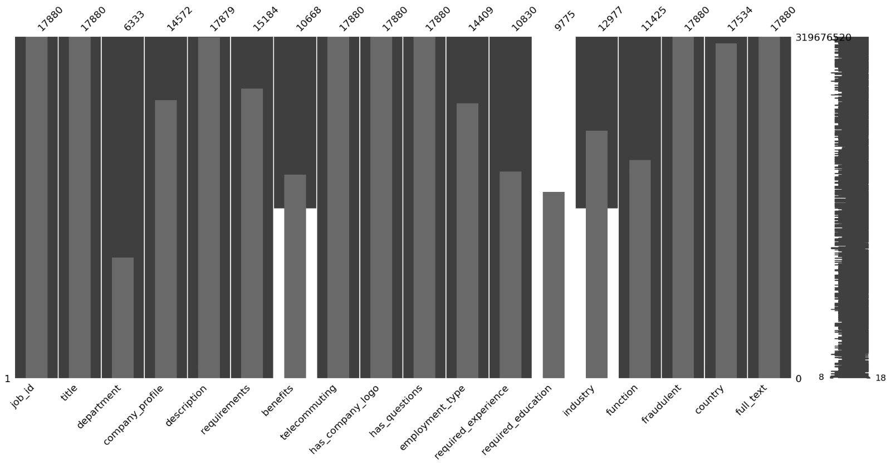

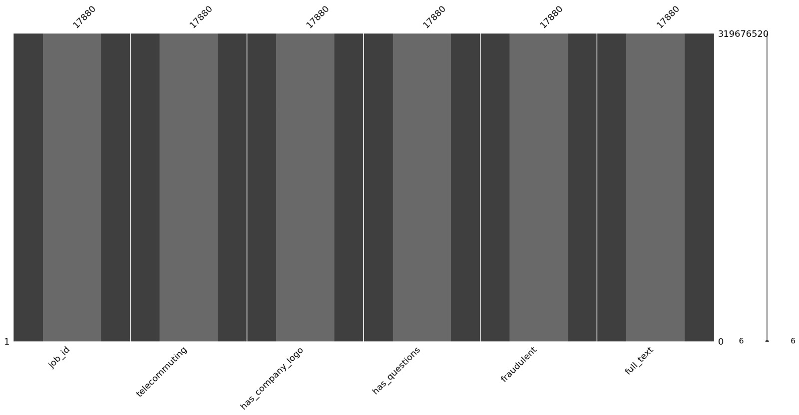

*REQUIRED EDUCATION VS FRAUDALENCE

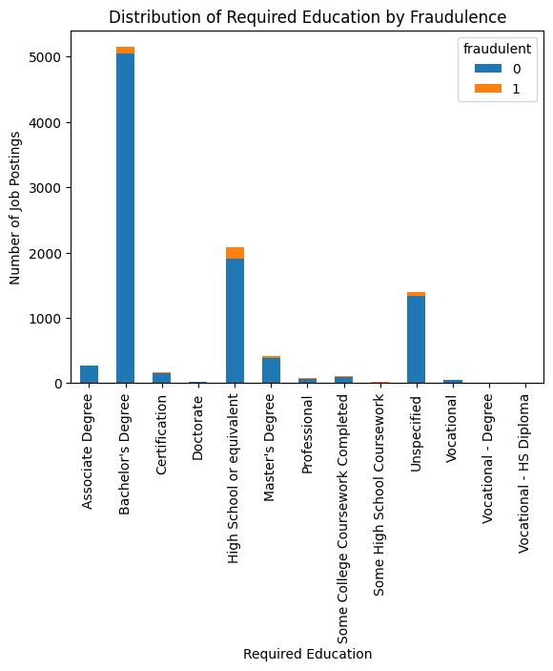

EMPLOYEMENT TYPE DISTRUIBUTION

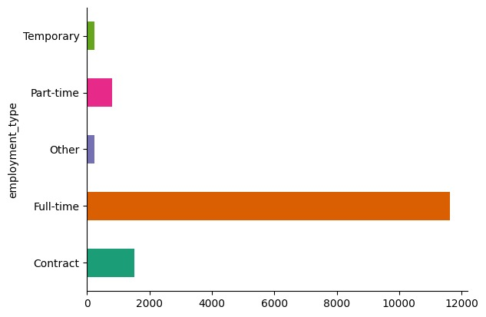

*EMPLOYEMENT TYPE VS REQUIRED EDUCATION

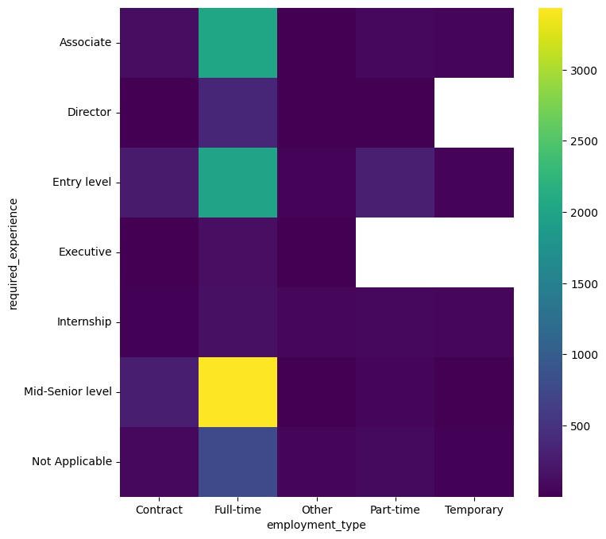

*JOB ID VS FREQUENCY

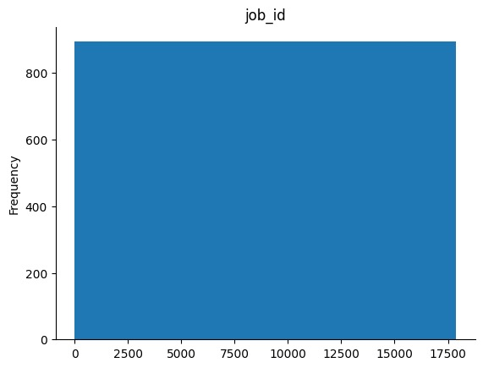

*EMPLOYEMENT TYPE DISTRIBUTION

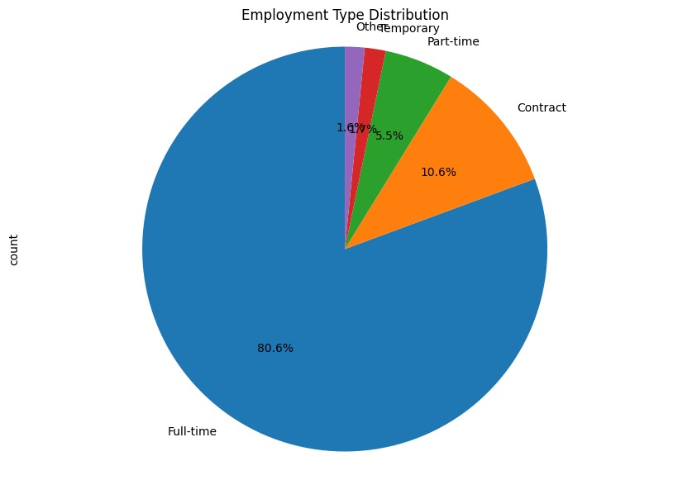

FRAUDLENT JOBS VS JOB INDUSTRY

